python -m pip install flask

Creating Rest API or end point for users, product, customer, account, transaction etc.
http protocol methods
Creating Rest API for Users
GET : /api/user -- get all users details
GET : /api/user/1 - get particular user using id may be user present or not
POST: api/creatUser store user details in array ie in memory or database can be mysql or mongo db
PUT : api/updateUser/1 -- > updating user name or age in array ie in memory database or mysql/mongo db
Put and patch : if we want to update particle information like name or age not both then you need to use patch. If you are planning to update all properties then you need to use put method.
DELETE : api/deleteUser/1 deleting particular user details.

To rest api we need plugin. Generally we use Post man plugin.

While testing using post man client you need do some setting as
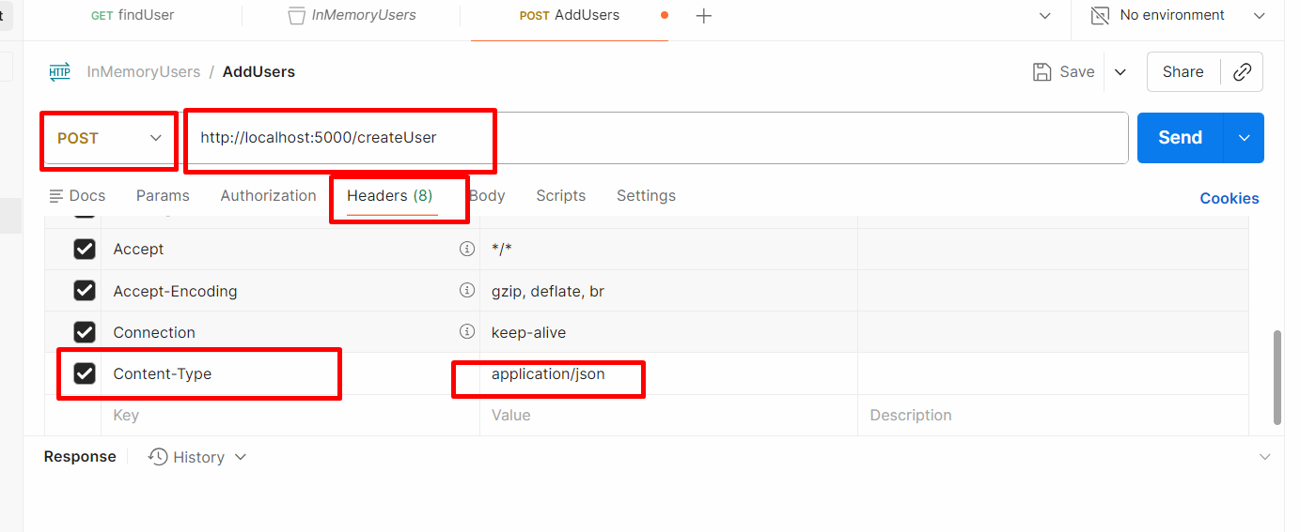
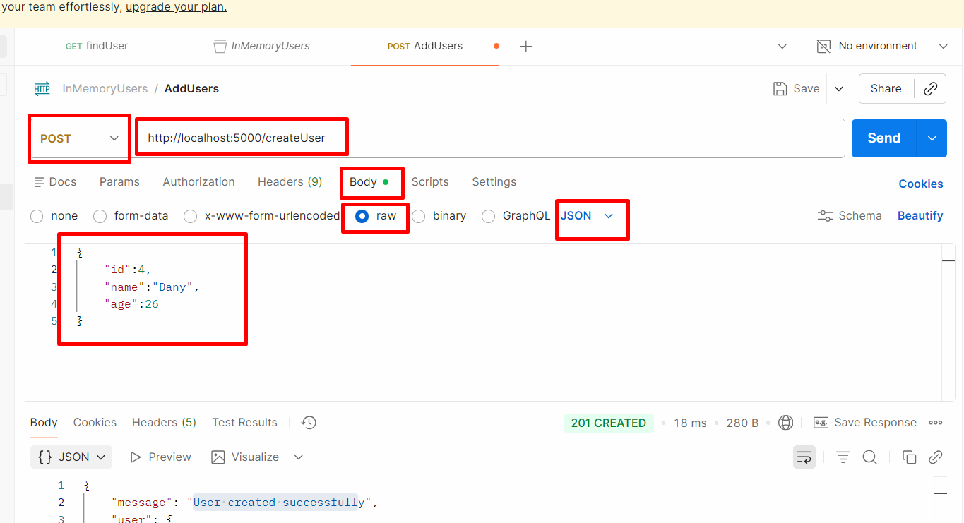

Creating rest api with mongo db database
python -m pip install mongoengine
python -m pip install flask

